POSITIVE BUCK CONVERTER use LT1170
Positive buck converters (Figure 21) using the LT1070 require a novel design approach because the negative side of the LT1070 switch is committed to the ground of the chip. This negative switch terminal is the inductor drive point in a positive buck converter. The ground pin of the LT1070 must therefore switch back and forth between the input voltage and converter ground. This is accomplished by tying the positive side of the switch (VSW) to the input supply, and using a peak-detected (C3, D3), bootstrapped supply voltage to operate the chip. As long as the LT1070 is switching, C3 will maintain the chip input-to-ground pin voltage at a voltage equal to the input supply voltage. It is important to keep the value of C3 to a minimum to ensure proper start-up of this topology. The 2.2μF value shown should not be increased unless careful tests are done to ensure proper start-up under worst-case light loads. If the LT1070 does not start, the lightly loaded output will go unregulated high. The minimum recommended load current in any case is 100mA.
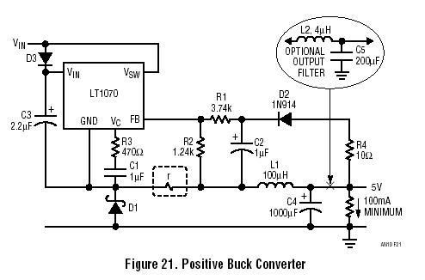
The most unusual aspect of this design is the manner in which output voltage information is delivered to the LT1070 feedback pin. This pin is switching along with the LT1070 ground pin to which it is referenced, so the feedback circuit must float on the switching ground pin and at the same time be proportional to the DC value of the output voltage.
This is accomplished by peak detecting the output voltage with D2 during the “off” time of the LT1070 switch. The voltage on the ground pin of the chip at this time is one diode drop (D1) negative with respect to system ground, because D1 is forward biased by load current flowing through L1. D2 also forward biases, giving a voltage across C2 of:
VC2 = VOUT – VD2 + VD1 (61)
VD1 = forward voltage of D1
VD2 = forward voltage of D2
The feedback network, R1/R2, is therefore biased with a voltage very nearly equal to output voltage, and the LT1070 will regulate output voltage according to:
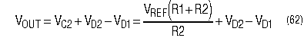
VREF = reference voltage of LT1070 = 1.244V
If VD1 is exactly equal to VD2, output regulation will be perfect, but the forward voltage of D1 is load current dependent, while D2 operates at a fixed average current of 1mA. This can cause output voltage variations of 100mV to 400mV if load current varies over a wide range. To minimize this effect, D1 should be conservatively rated with respect to operating current so that the effect of parasitic series resistance is minimized. The unit shown is rated at 10A average current. D1 should also be a fast turnon type. (See diode discussion elsewhere in this application section.) A long turn-on time for D1 allows C2 to charge to a voltage higher than VOUT, creating an abnormally low output voltage. R4 is added to minimize this effect. A Schottky diode is recommended for D1 because these diodes have very fast switching times and their low forward voltage improves efficiency, especially for low output voltage.
Load regulation can be significantly improved in this application by inserting a small resistor (r, shown in dashed box) between D1 and L1. The voltage across r will be equal to (r)(IOUT). This voltage increases the voltage across R2, forcing the output voltage to rise under load. Perfect load regulation will result if the output rise created by r just cancels the output drop caused by the increased forward voltage of D1. The required value for r is found from:
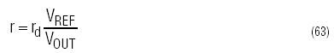
rd = forward series resistance of D1
VREF = LT1070 reference voltage = 1.244V
Load regulation will never be perfect because rd varies slightly from unit to unit and it is not constant with load current, but regulation better than 2% with VOUT = 5V is easily achieved even with load current varying over a 5:1 range. For higher output voltages, load regulation is even better.
For the circuit shown, with rd = 0.05Ω, r is:
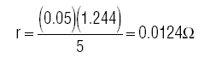
This is most easily obtained by using 9 inches of #22 hookup wire.
Output voltage is determined by R1 and R2:
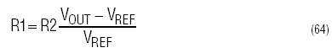
R2 is normally fixed at 1.24k to set divider current to 1mA. This equation assumes that VD1 = VD2. A slight adjustment in R1 will be required if VD1 ≠ VD2.
Duty Cycle Limitations
Maximum duty cycle for the LT1070 is 90%. This limits the minimum input voltage in buck regulators. Duty cycle can be calculated from:
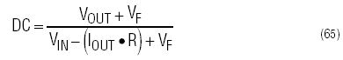
VF = forward voltage of D1
R = “on” resistance of LT1070 switch Rearranging this formula for VIN yields:
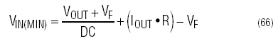
With a maximum duty cycle of 90%, (0.9) and VOUT = 5V,VF = 0.6V, R = 0.2Ω, 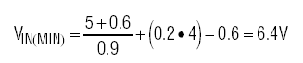
Inductor
The energy storage inductor in a buck regulator functions as both an energy conversion element and as an output ripple filter. This double duty often saves the cost of an additional output filter, but it complicates the process of finding a good compromise for the value of the inductor.
Large values give maximum power output and low output ripple voltage, but they also can be bulky and give poor transient response. A reasonable starting point is to select a maximum peak-to-peak ripple current, (ΔI). This yields a value for L1 of:
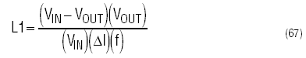
f = LT1070 operating frequency ≈40kHz
ΔI = peak-to-peak inductor ripple current
With the circuit shown, VIN = 16V, VOUT = 5V and ΔI set at 20% of 3.5A = 0.7A:
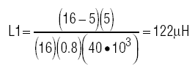
The ripple current in L1 reduces the maximum output current by one-half ΔI. For lower output currents this is no problem, but for maximum output power, L1 may be raised by a factor of two to three. For lower output powers, L1 can be reduced to save on size and cost. Discontinuous mode operation will occur even near full load if L1 is reduced far enough. The LT1070 is not affected by discontinuous operation per se, but maximum output power is significantly reduced in discontinuous mode designs:
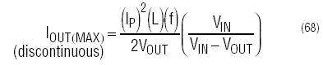
IP = LT1070 peak switch current(discontinuous)
With L1 = 10μH, for instance, and IP = 5A:
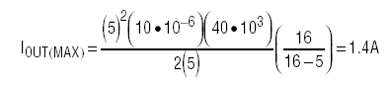
Efficiency is also reduced with discontinuous operation because of increased switch dissipation. The load current where a buck regulator changes from continuous to discontinuous operation is:
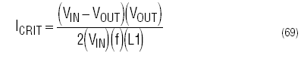
With a 100μH value of L1, inductor current will go discontinuous at:
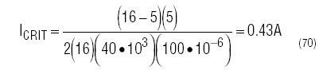
ICRIT can never exceed 2.5A (one half maximum LT1070 switch current).
Peak inductor current in a buck regulator with continuous mode operation is:
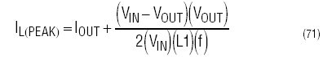
With IOUT = 3.5A and L1 = 100μH:
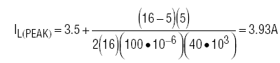
The core used for L1 must be able to handle 3.93A peak current without saturating. Peak inductor currents in discontinuous mode are much higher than output current:
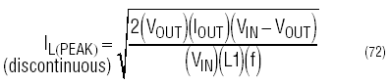
For L1 = 10μH, IOUT = 1A:
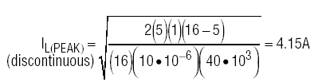
The 10μH inductor, at 1A output current, must be sized to handle 4.14A peak current.
Output Voltage Ripple
See Negative Buck Regulator section for calculation of output ripple.
Output Capacitor
C4 is chosen for output voltage ripple considerations. Its ESR (effective series resistance) is the most important parameter. For details, see Negative Buck Regulators section.
Output Filter
For very low output voltage ripple, the value of C4 may become prohibitively high. An output filter, L2 and C5, may be used to reduce output ripple. See Output Filter section for details.

